**MACHINE LEARNING**

Machine learning is a method of data analysis that automates analytical model building. It is a branch of [artificial intelligence](https://www.sas.com/en_in/insights/analytics/what-is-artificial-intelligence.html) based on the idea that systems can learn from data, identify patterns and make decisions with minimal human intervention.

## Why is machine learning important?

Resurging interest in machine learning is due to the same factors that have made [data mining](https://www.sas.com/en_in/insights/analytics/data-mining.html) and Bayesian analysis more popular than ever. Things like growing volumes and varieties of available data, computational processing that is cheaper and more powerful, and affordable data storage.

All of these things mean it's possible to quickly and automatically produce models that can analyze bigger, more complex data and deliver faster, more accurate results – even on a very large scale. And by building precise models, an organization has a better chance of identifying profitable opportunities – or avoiding unknown risks

## Evolution of machine learning

Because of new computing technologies, machine learning today is not like machine learning of the past. It was born from pattern recognition and the theory that computers can learn without being programmed to perform specific tasks; researchers interested in artificial intelligence wanted to see if computers could learn from data. The iterative aspect of machine learning is important because as models are exposed to new data, they can independently adapt. They learn from previous computations to produce reliable, repeatable decisions and results. It’s a science that’s not new – but one that has gained fresh momentum.

While many machine learning [algorithms have been around for a long time](https://www.sas.com/en_in/insights/articles/analytics/machine-learning-algorithms-guide.html), the ability to automatically apply complex mathematical calculations to [big data](https://www.sas.com/en_in/insights/big-data/what-is-big-data.html) – over and over, faster and faster – is a recent development. Here are a few widely publicized examples of machine learning applications you may be familiar with:

* The heavily hyped, self-driving Google car? The essence of machine learning.
* Online recommendation offers such as those from Amazon and Netflix? Machine learning applications for everyday life.
* Knowing what customers are saying about you on Twitter? Machine learning combined with linguistic rule creation.
* Fraud detection? One of the more obvious, important uses in our world today.

## Why is machine learning important?

Resurging interest in machine learning is due to the same factors that have made [data mining](https://www.sas.com/en_in/insights/analytics/data-mining.html) and Bayesian analysis more popular than ever. Things like growing volumes and varieties of available data, computational processing that is cheaper and more powerful, and affordable data storage.

All of these things mean it's possible to quickly and automatically produce models that can analyze bigger, more complex data and deliver faster, more accurate results – even on a very large scale. And by building precise models, an organization has a better chance of identifying profitable opportunities – or avoiding unknown risks.

### **What's required to create good machine learning systems?**

* Data preparation capabilities.
* Algorithms – basic and advanced.
* Automation and iterative processes.
* Scalability.
* Ensemble modeling.

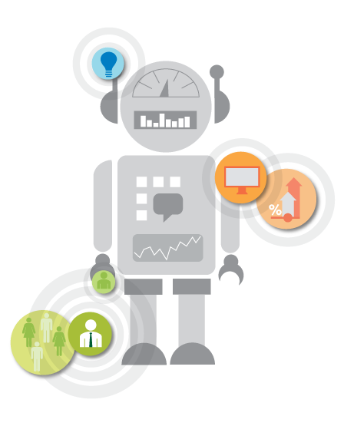

### **Did you know?**

* In machine learning, a target is called a label.
* In statistics, a target is called a dependent variable.
* A variable in statistics is called a feature in machine learning.
* A transformation in statistics is called feature creation in machine learning.

### **Who's using it?**

#### **Most industries working with large amounts of data have recognized the value of machine learning technology. By gleaning insights from this data – often in real-time – organizations can work more efficiently or gain an advantage over competitors.**

### [**Financial services**](https://www.sas.com/en_in/industry/banking.html)

Banks and other businesses in the financial industry use machine learning technology for two key purposes: to identify important insights in data, and prevent fraud. The insights can identify investment opportunities, or help investors know when to trade. Data mining can also identify clients with high-risk profiles, or use cyber surveillance to pinpoint warning signs of fraud.

### [**Government**](https://www.sas.com/en_in/industry/government.html)

Government agencies such as public safety and utilities have a particular need for machine learning since they have multiple sources of data that can be mined for insights. Analyzing sensor data, for example, identifies ways to increase efficiency and save money. Machine learning can also help detect [fraud and minimize identity theft](https://www.sas.com/en_in/insights/data-management/cloud-computing.html).

### [**Health care**](https://www.sas.com/en_in/industry/health-care.html)

Machine learning is a fast-growing trend in the health care industry, thanks to the advent of wearable devices and sensors that can use data to assess a patient's health in real-time. The technology can also help medical experts analyze data to identify trends or red flags that may lead to improved diagnoses and treatment.

### [**Retail**](https://www.sas.com/en_in/industry/retail.html)

Websites recommending items you might like based on previous purchases are using machine learning to analyze your buying history.  Retailers rely on machine learning to capture data, analyze it and use it to personalize a shopping experience, implement a [marketing campaign](https://www.sas.com/en_in/insights/marketing.html), [price optimization,](https://www.sas.com/en_in/industry/retail/solution/merchandise-planning-price-optimization.html) merchandise [supply planning](https://www.sas.com/en_in/industry/retail/solution/supply-demand-planning.html), and [customer insights](https://www.sas.com/en_in/industry/retail/solution/customer-insight.html).

### [**Oil and gas**](https://www.sas.com/en_in/industry/oil-gas.html)

Finding new energy sources. Analyzing minerals in the ground. Predicting refinery sensor failure. Streamlining oil distribution to make it more efficient and cost-effective. The number of machine learning use cases for this industry is vast – and still expanding.

### [**Transportation**](https://www.sas.com/en_in/industry/travel-transportation.html)

Analyzing data to identify patterns and trends is key to the transportation industry, which relies on making routes more efficient and predicting potential problems to increase profitability. The data analysis and modeling aspects of machine learning are important tools to delivery companies, public transportation, and other transportation.

## What are some popular machine learning methods?

Two of the most widely adopted machine learning methods are **supervised learning** and **unsupervised learning** – but there are also other methods of machine learning. Here's an overview of the most popular types.

**Supervised learning**algorithms are trained using labeled examples, such as an input where the desired output is known. For example, a piece of equipment could have data points labeled either “F” (failed) or “R” (runs). The learning algorithm receives a set of inputs along with the corresponding correct outputs, and the algorithm learns by comparing its actual output with correct outputs to find errors. It then modifies the model accordingly. Through methods like classification, regression, prediction, and gradient boosting, supervised learning uses patterns to predict the values of the label on additional unlabeled data. Supervised learning is commonly used in applications where historical data predicts likely future events. For example, it can anticipate when credit card transactions are likely to be fraudulent or which insurance customer is likely to file a claim.

**Unsupervised learning**is used against data that has no historical labels. The system is not told the "right answer." The algorithm must figure out what is being shown. The goal is to explore the data and find some structure within it. Unsupervised learning works well on transactional data. For example, it can identify segments of customers with similar attributes who can then be treated similarly in marketing campaigns. Or it can find the main attributes that separate customer segments from each other. Popular techniques include self-organizing maps, nearest-neighbor mapping, k-means clustering, and singular value decomposition. These algorithms are also used to segment text topics, recommend items and identify data outliers.

What Is Regression?

Regression is a statistical method used in finance, investing, and other disciplines that attempt to determine the strength and character of the relationship between one dependent variable (usually denoted by Y) and a series of other variables (known as independent variables).

The two basic types of regression are:

**simple linear regression**

**multiple linear regression**

Although there are non-linear regression methods for more complicated data and analysis. Simple linear regression uses one independent variable to explain or predict the outcome of the dependent variable Y, while multiple linear regression uses two or more independent variables to predict the outcome

The general form of each type of regression is:

* **Simple linear regression:** Y = a + bx + u
* **Multiple linear regression:** Y = a + b1X1+ b2X2 + b3X3 + ... + best + u

Where:

* Y = the variable that you are trying to predict (dependent variable).
* X = the variable that you are using to predict Y (independent variable).
* a = the intercept.
* b = the slope.
* u = the regression residual.

Simple Linear Regression is a type of Regression algorithm that models the relationship between a dependent variable and a single independent variable. The relationship shown by a Simple Linear Regression model is linear or a sloped straight line, hence it is called Simple Linear Regression.

The key point in Simple Linear Regression is that the ***dependent variable must be a continuous/real value***. However, the independent variable can be measured on continuous or categorical values.

Simple Linear regression algorithm has mainly two objectives:

* **Model the relationship between the two variables.** Such as the relationship between income and expenditure, experience and Salary, etc.
* **Forecasting new observations.** Such as Weather forecasting according to temperature, Revenue of a company according to the investments in a year, etc

## Simple Linear Regression Model:

The Simple Linear Regression model can be represented using the below equation:

y= a0+a1x+ ε

Where,

**a0= It is the intercept of the Regression line (can be obtained putting x=0)**  
**a1= It is the slope of the regression line, which tells whether the line is increasing or decreasing.**  
**ε = The error term. (For a good model it will be negligible)**

Here we are taking a dataset that has two variables: salary (dependent variable) and experience (Independent variable). The goals of this problem are:

* **We want to find out if there is any correlation between these two variables**
* **We will find the best fit line for the dataset.**
* **How the dependent variable is changing by changing the independent variable.**

# **Multiple Linear Regression**

In the previous topic, we have learned about Simple Linear Regression, where a single Independent/Predictor(X) variable is used to model the response variable (Y). But there may be various cases in which the response variable is affected by more than one predictor variable; for such cases, the Multiple Linear Regression algorithm is used.

Moreover, Multiple Linear Regression is an extension of Simple Linear regression as it takes more than one predictor variable to predict the response variable. We can define it as:

Multiple Linear Regression is one of the important regression algorithms which models the linear relationship between a single dependent continuous variable and more than one independent variable.

**Example:**

Prediction of CO2 emission based on engine size and number of cylinders in a car.

**Some key points about MLR:**

* For MLR, the dependent or target variable(Y) must be the continuous/real, but the predictor or independent variable may be of the continuous or categorical form.
* Each feature variable must model the linear relationship with the dependent variable.
* MLR tries to fit a regression line through a multidimensional space of data points.

### **MLR equation:**

In Multiple Linear Regression, the target variable(Y) is a linear combination of multiple predictor variables x1, x2, x3, ...,xn. Since it is an enhancement of Simple Linear Regression, so the same is applied for the multiple linear regression equation, the equation becomes:

1. Y= b<sub>0</sub>+b<sub>1</sub>x<sub>1</sub>+ b<sub>2</sub>x<sub>2</sub>+ b<sub>3</sub>x<sub>3</sub>+...... bnxn       ............... (a)

Where,

**Y= Output/Response variable**

**b0, b1, b2, b3 , bn....= Coefficients of the model.**

**x1, x2, x3, x4,...= Various Independent/feature variable**

### **Assumptions for Multiple Linear Regression:**

* A **linear relationship** should exist between the Target and predictor variables.
* The regression residuals must be **normally distributed**.
* MLR assumes independent **multicollinearity** (correlation between the independent variable) in data.

### **Implementation of Multiple Linear Regression model using Python:**

To implement MLR using Python, we have the below problem:

**Problem Description:**

We have a dataset of **50 start-up companies**. This dataset contains five main information: **R&D Spend, Administration Spend, Marketing Spend, State, and Profit for a financial year**. Our goal is to create a model that can easily determine which company has a maximum profit, and which is the most affecting factor for the profit of a company.

Since we need to find the Profit, it is the dependent variable, and the other four variables are independent. Below are the main steps of deploying the MLR model:

1. **Data Pre-processing Steps**
2. **Fitting the MLR model to the training set**
3. **Predicting the result of the test se**

# **Logistic Regression in Machine Learning**

* Logistic regression is one of the most popular Machine Learning algorithms, which comes under the Supervised Learning technique. It is used for predicting the categorical dependent variable using a given set of independent variables.
* Logistic regression predicts the output of a categorical dependent variable. Therefore the outcome must be a categorical or discrete value. It can be either Yes or No, 0 or 1, true or False, etc. but instead of giving the exact value as 0 and 1, **it gives the probabilistic values which lie between 0 and 1**.
* Logistic Regression is much similar to Linear Regression except that how they are used. Linear Regression is used for solving Regression problems, whereas **Logistic regression is used for solving the classification problems**.
* In Logistic regression, instead of fitting a regression line, we fit an "S" shaped logistic function, which predicts two maximum values (0 or 1).
* The curve from the logistic function indicates the likelihood of something such as whether the cells are cancerous or not, a mouse is obese or not based on its weight, etc.
* Logistic Regression is a significant machine learning algorithm because it can provide probabilities and classify new data using continuous and discrete datasets.
* Logistic Regression can be used to classify the observations using different types of data and can easily determine the most effective variables used for the classification. The below image is showing the logistic function:

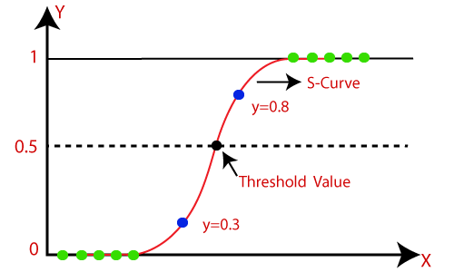

Logistic Regression Equation:

The Logistic regression equation can be obtained from the Linear Regression equation. The mathematical steps to get Logistic Regression equations are given below:

* We know the equation of the straight line can be written as:

Logistic Regression in Machine Learning

* In Logistic Regression y can be between 0 and 1 only, so for this let's divide the above equation by (1-y):

Logistic Regression in Machine Learning

* But we need range between -[infinity] to +[infinity], then take the logarithm of the equation it will become:

Logistic Regression in Machine Learning

The above equation is the final equation for Logistic Regression.

Type of Logistic Regression:

Based on the categories, Logistic Regression can be classified into three types:

* **Binomial:** In binomial Logistic regression, there can be only two possible types of the dependent variables, such as 0 or 1, Pass or Fail, etc.
* **Multinomial:** In multinomial Logistic regression, there can be 3 or more possible unordered types of the dependent variable, such as "cat", "dogs", or "sheep"
* **Ordinal:** In ordinal Logistic regression, there can be 3 or more possible ordered types of dependent variables, such as "low", "Medium", or "High".

**Steps in Logistic Regression:** To implement the Logistic Regression using Python, we will use the same steps as we have done in previous topics of Regression. Below are the steps:

* Data Pre-processing step
* Fitting Logistic Regression to the Training set
* Predicting the test result
* Test accuracy of the result(Creation of Confusion matrix)
* Visualizing the test set result.

# **Clustering in Machine Learning**

Clustering or cluster analysis is a machine learning technique, which groups the unlabelled dataset. It can be defined as **"A way of grouping the data points into different clusters, consisting of similar data points. The objects with the possible similarities remain in a group that has less or no similarities with another group."**

It does it by finding some similar patterns in the unlabelled dataset such as shape, size, color, behavior, etc., and divides them as per the presence and absence of those similar patterns.

It is an [unsupervised learning](https://www.javatpoint.com/unsupervised-machine-learning)

method, hence no supervision is provided to the algorithm, and it deals with the unlabeled dataset.

# **H-Clustering in Machine Learning**

Hierarchical clustering is another unsupervised machine learning algorithm, which is used to group the unlabeled datasets into a cluster and is also known as **hierarchical cluster analysis** or HCA.

In this algorithm, we develop the hierarchy of clusters in the form of a tree, and this tree-shaped structure is known as the **dendrogram**.

Sometimes the results of K-means clustering and hierarchical clustering may look similar, but they both differ depending on how they work. As there is no requirement to predetermine the number of clusters as we did in the K-Means algorithm.

The hierarchical clustering technique has two approaches:

1. **Agglomerative:** Agglomerative is a **bottom-up** approach, in which the algorithm starts with taking all data points as single clusters and merging them until one cluster is left.
2. **Divisive:** Divisive algorithm is the reverse of the agglomerative algorithm as it is a **top-down approach.**

### **Why hierarchical clustering?**

As we already have other [clustering](https://www.javatpoint.com/clustering-in-machine-learning) algorithms such as [**K-Means Clustering**](https://www.javatpoint.com/k-means-clustering-algorithm-in-machine-learning), then why do we need hierarchical clustering? So, as we have seen in the K-means clustering that there are some challenges with this algorithm, which are a predetermined number of clusters, and it always tries to create clusters of the same size. To solve these two challenges, we can opt for the hierarchical clustering algorithm because, in this algorithm, we don't need to know the predefined number of clusters.

In this topic, we will discuss the Agglomerative Hierarchical clustering algorithm.

## Agglomerative Hierarchical clustering

The agglomerative hierarchical clustering algorithm is a popular example of HCA. To group the datasets into clusters, it follows the **bottom-up approach**. It means, this algorithm considers each dataset as a single cluster at the beginning and then starts combining the closest pair of clusters. It does this until all the clusters are merged into a single cluster that contains all the datasets.

This hierarchy of clusters is represented in the form of the dendrogram.

## How does Agglomerative Hierarchical clustering Work?

The working of the AHC algorithm can be explained using the below steps:

* **Step-1:** Create each data point as a single cluster. Let's say there are N data points, so the number of clusters will also be N.  
  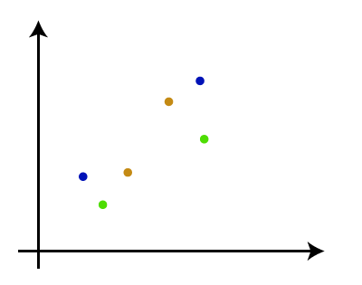
* **Step-2:** Take two closest data points or clusters and merge them to form one cluster. So, there will now be N-1 clusters.  
  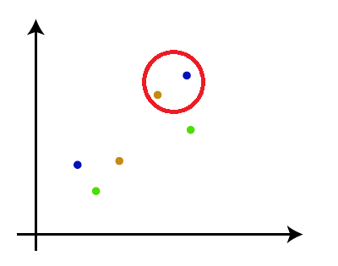
* **Step-3**: Again, take the two closest clusters and merge them to form one cluster. There will be N-2 clusters.  
  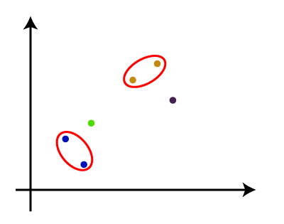
* **Step-4:** Repeat Step 3 until only one cluster is left. So, we will get the following clusters. Consider the below images:  
  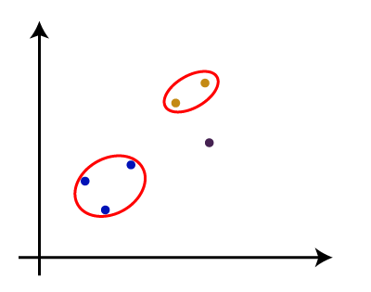  
  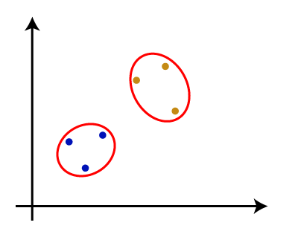  
  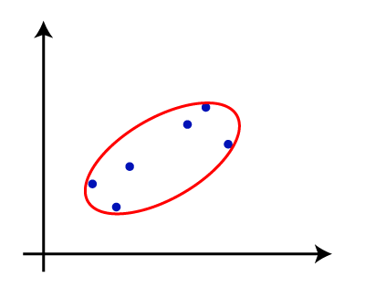
* **Step-5:** Once all the clusters are combined into one big cluster, develop the dendrogram to divide the clusters as per the problem.

#### **Note: To better understand hierarchical clustering, it is advised to have a look at k-means clustering**

### **Measure for the distance between two clusters**

As we have seen, the **closest distance** between the two clusters is crucial for hierarchical clustering. There are various ways to calculate the distance between two clusters, and these ways decide the rule for clustering. These measures are called **Linkage methods**. Some of the popular linkage methods are given below:

1. **Single Linkage:** It is the Shortest Distance between the closest points of the clusters. Consider the below image:  
   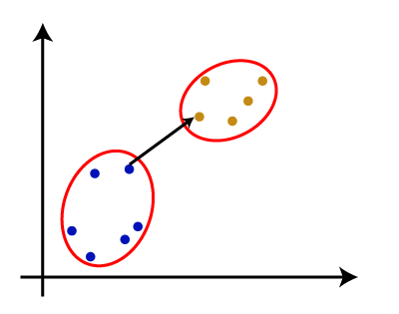
2. **Complete Linkage:** It is the farthest distance between the two points of two different clusters. It is one of the popular linkage methods as it forms tighter clusters than single-linkage.  
   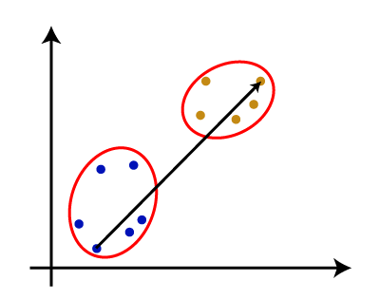
3. **Average Linkage:** It is the linkage method in which the distance between each pair of datasets is added up and then divided by the total number of datasets to calculate the average distance between two clusters. It is also one of the most popular linkage methods.
4. **Centroid Linkage:** It is the linkage method in which the distance between the centroid of the clusters is calculated. Consider the below image:  
   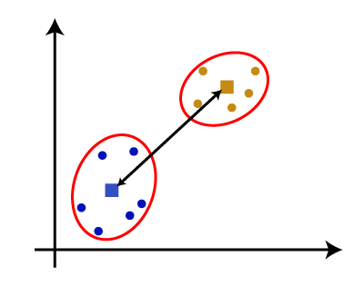

From the above-given approaches, we can apply any of them according to the type of problem or business requirement.

### **Working of Dendrogram in Hierarchical clustering**

The dendrogram is a tree-like structure that is mainly used to store each step as a memory that the HC algorithm performs. In the dendrogram plot, the Y-axis shows the Euclidean distances between the data points, and the x-axis shows all the data points of the given dataset.

The working of the dendrogram can be explained using the below diagram:

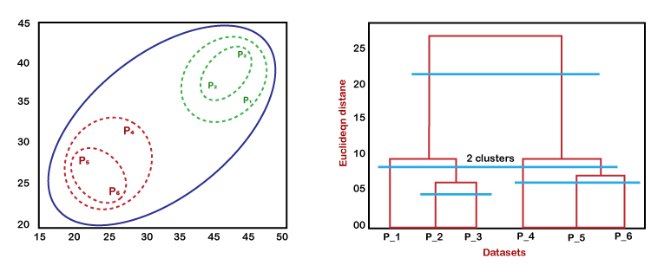

In the above diagram, the left part is showing how clusters are created in agglomerative clustering, and the right part is showing the corresponding dendrogram.

* As we have discussed above, firstly, the datapoints P2 and P3 combine and form a cluster, correspondingly a dendrogram is created, which connects P2 and P3 with a rectangular shape. The height is decided according to the Euclidean distance between the data points.
* In the next step, P5 and P6 form a cluster, and the corresponding dendrogram is created. It is higher than of previous, as the Euclidean distance between P5 and P6 is a little bit greater than the P2 and P3.
* Again, two new dendrograms are created that combine P1, P2, and P3 in one dendrogram, and P4, P5, and P6, in another dendrogram.
* At last, the final dendrogram is created that combines all the data points.

We can cut the dendrogram tree structure at any level as per our requirement.

# **K-Means Clustering Algorithm**

K-Means Clustering is an unsupervised learning algorithm that is used to solve clustering problems in machine learning or data science. In this topic, we will learn what is K-means clustering algorithm, how the algorithm works, along with the Python implementation of k-means clustering.

## What is K-Means Algorithm?

K-Means Clustering is an [Unsupervised Learning algorithm](https://www.javatpoint.com/unsupervised-machine-learning)

, which groups the unlabeled dataset into different clusters. Here K defines the number of pre-defined clusters that need to be created in the process, as if K=2, there will be two clusters, and for K=3, there will be three clusters, and so on.

It is an iterative algorithm that divides the unlabeled dataset into k different clusters in such a way that each dataset belongs to only one group that has similar properties.

It allows us to cluster the data into different groups and is a convenient way to discover the categories of groups in the unlabeled dataset on its own without the need for any training.

It is a centroid-based algorithm, where each cluster is associated with a centroid. The main aim of this algorithm is to minimize the sum of distances between the data point and their corresponding clusters.

The algorithm takes the unlabeled dataset as input, divides the dataset into k-number of clusters, and repeats the process until it does not find the best clusters. The value of k should be predetermined in this algorithm.

The k-means [clustering](https://www.javatpoint.com/clustering-in-machine-learning)

The algorithm mainly performs two tasks:

* Determines the best value for K center points or centroids by an iterative process.
* Assigns each data point to its closest k-center. Those data points which are near to the particular k-center, create a cluster.

Hence each cluster has datapoints with some commonalities, and it is away from other clusters.

The below diagram explains the working of the K-means Clustering Algorithm:

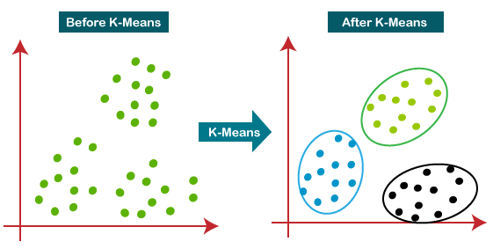

## How does the K-Means Algorithm Work?

The working of the K-Means algorithm is explained in the below steps:

**Step-1:** Select the number K to decide the number of clusters.

**Step-2:** Select random K points or centroids. (It can be other from the input dataset).

**Step-3:** Assign each data point to their closest centroid, which will form the predefined K clusters.

**Step-4:** Calculate the variance and place a new centroid of each cluster.

**Step-5:** Repeat the third steps, which means reassigning each datapoint to the new closest centroid of each cluster.

**Step-6:** If any reassignment occurs, then go to step-4 else go to FINISH.

**Step-7**: The model is ready.

Let's understand the above steps by considering the visual plots:

Suppose we have two variables M1 and M2. The x-y axis scatter plot of these two variables is given below:

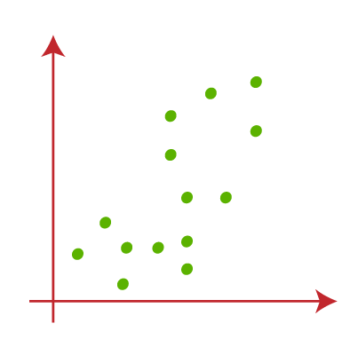

* Let's take number k of clusters, i.e., K=2, to identify the dataset and to put them into different clusters. It means here we will try to group these datasets into two different clusters.
* We need to choose some random k points or centroid to form the cluster. These points can be either the points from the dataset or any other point. So, here we are selecting the below two points ask points, which are not part of our dataset. Consider the below image:  
  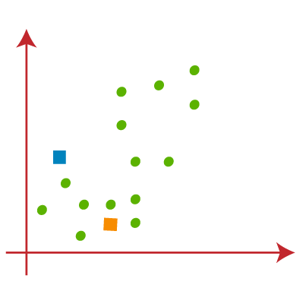
* Now we will assign each data point of the scatter plot to its closest K-point or centroid. We will compute it by applying some mathematics that we have studied to calculate the distance between two points. So, we will draw a median between both the centroids. Consider the below image:  
  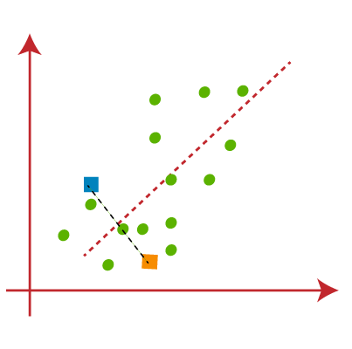

From the above image, it is clear that the points left side of the line is near to the K1 or blue centroid, and points to the right of the line are close to the yellow centroid. Let's color them blue and yellow for clear visualization.

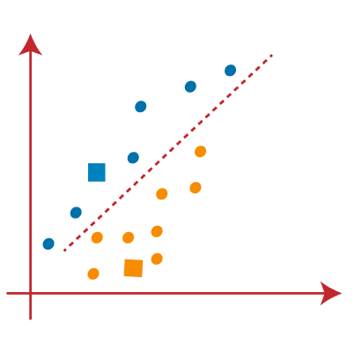

* As we need to find the closest cluster, we will repeat the process by choosing **a new centroid**. To choose the new centroids, we will compute the center of gravity of these centroids, and will find new centroids as below:  
  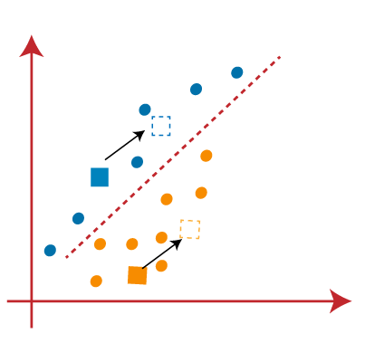
* Next, we will reassign each datapoint to the new centroid. For this, we will repeat the same process of finding a median line. The median will be like the below image:  
  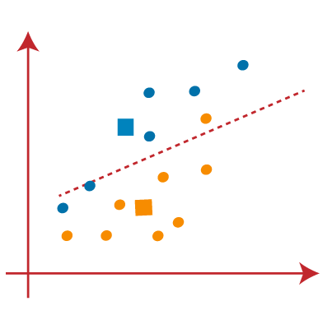

From the above image, we can see, one yellow point is on the left side of the line, and two blue points are right to the line. So, these three points will be assigned to new centroids.

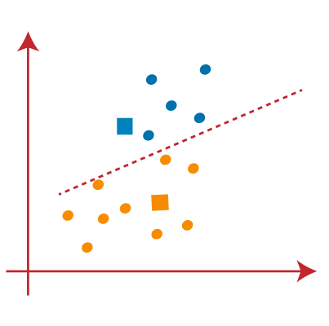

As reassignment has taken place, we will again go to step-4, which is finding new centroids or K-points.

* We will repeat the process by finding the center of gravity of centroids, so the new centroids will be as shown in the below image:  
  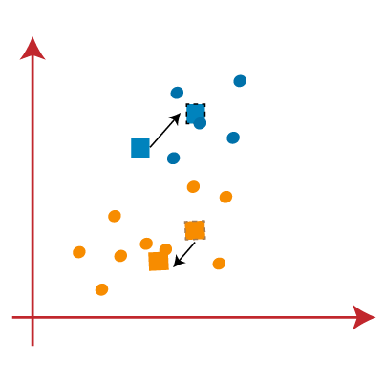
* As we got the new centroids so again will draw the median line and reassign the data points. So, the image will be:  
  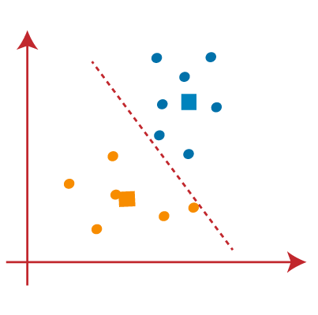
* We can see in the above image; there are no dissimilar data points on either side of the line, which means our model is formed. Consider the below image:  
  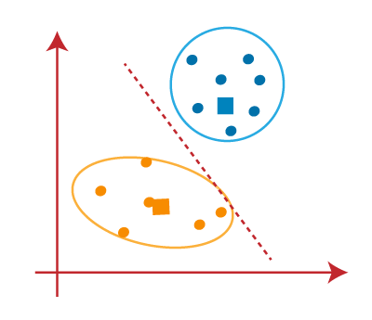

As our model is ready, so we can now remove the assumed centroids, and the two final clusters will be as shown in the below image:

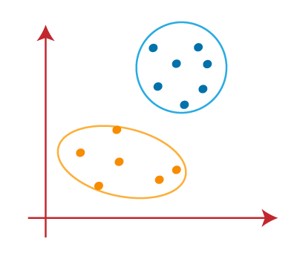

## How to choose the value of "K number of clusters" in K-means Clustering?

The performance of the K-means clustering algorithm depends upon the highly efficient clusters that it forms. But choosing the optimal number of clusters is a big task. There are some different ways to find the optimal number of clusters, but here we are discussing the most appropriate method to find the number of clusters or value of K. The method is given below:

### **Elbow Method**

The Elbow method is one of the most popular ways to find the optimal number of clusters. This method uses the concept of WCSS value. **WCSS** stands for **Within Cluster Sum of Squares**, which defines the total variations within a cluster. The formula to calculate the value of WCSS (for 3 clusters) is given below:

WCSS= ∑Pi in Cluster1 distance(Pi C1)2 +∑Pi in Cluster2distance(Pi C2)2+∑Pi in CLuster3 distance(Pi C3)2

In the above formula of WCSS,

∑Pi in Cluster1 distance(Pi C1)2: It is the sum of the square of the distances between each data point and its centroid within a cluster1 and the same for the other two terms.

To measure the distance between data points and centroid, we can use any method such as Euclidean distance or Manhattan distance.

To find the optimal value of clusters, the elbow method follows the below steps:

* It executes the K-means clustering on a given dataset for different K values (ranges from 1-10).
* For each value of K, calculate the WCSS value.
* Plots a curve between calculated WCSS values and the number of clusters K.
* The sharp point of bend or a point of the plot looks like an arm, then that point is considered as the best value of K.

Since the graph shows the sharp bend, which looks like an elbow, hence it is known as the elbow method. The graph for the elbow method looks like the below image:

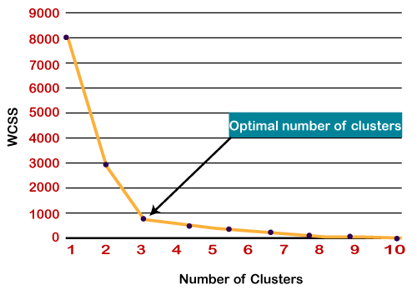

# **Principal Component Analysis**

Principal Component Analysis is an unsupervised learning algorithm that is used for the dimensionality reduction in [machine learning](https://www.javatpoint.com/machine-learning)

. It is a statistical process that converts the observations of correlated features into a set of linearly uncorrelated features with the help of orthogonal transformation. These new transformed features are called the **Principal Components**. It is one of the popular tools that is used for exploratory data analysis and predictive modeling. It is a technique to draw strong patterns from the given dataset by reducing the variances.

PCA generally tries to find the lower-dimensional surface to project the high-dimensional data.

PCA works by considering the variance of each attribute because the high attribute shows the good split between the classes, and hence it reduces the dimensionality. Some real-world applications of PCA are **image processing, movie recommendation systems, optimizing the power allocation in various communication channels.** It is a feature extraction technique, so it contains the important variables and drops the least important variable.

The PCA algorithm is based on some mathematical concepts such as:

29.7M

574

Java Try Catch

* Variance and Covariance
* Eigenvalues and Eigen factors

Some common terms used in PCA algorithm:

* **Dimensionality:** It is the number of features or variables present in the given dataset. More easily, it is the number of columns present in the dataset.
* **Correlation:** It signifies how strongly two variables are related to each other. Such as if one changes, the other variable also gets changed. The correlation value ranges from -1 to +1. Here, -1 occurs if variables are inversely proportional to each other, and +1 indicates that variables are directly proportional to each other.
* **Orthogonal:** It defines that variables are not correlated to each other, and hence the correlation between the pair of variables is zero.
* **Eigenvectors:** If there is a square matrix M, and a non-zero vector v is given. Then v will be eigenvector if Av is the scalar multiple of v.
* **Covariance Matrix:** A matrix containing the covariance between the pair of variables is called the Covariance Matrix.

### **Principal Components in PCA**

As described above, the transformed new features or the output of PCA are the Principal Components. The number of these PCs is either equal to or less than the original features present in the dataset. Some properties of these principal components are given below:

* The principal component must be the linear combination of the original features.
* These components are orthogonal, i.e., the correlation between a pair of variables is zero.
* The importance of each component decreases when going to 1 to n, it means the 1 PC has the most importance, and n PC will have the least importance.

### **Steps for PCA algorithm**

1. **Getting the dataset**  
   Firstly, we need to take the input dataset and divide it into two subparts X and Y, where X is the training set, and Y is the validation set.
2. **Representing data into a structure**  
   Now we will represent our dataset into a structure. Such as we will represent the two-dimensional matrix of independent variable X. Here each row corresponds to the data items, and the column corresponds to the Features. The number of columns is the dimensions of the dataset.
3. **Standardizing the data**  
   In this step, we will standardize our dataset. Such as in a particular column, the features with high variance are more important compared to the features with lower variance.  
   If the importance of features is independent of the variance of the feature, then we will divide each data item in a column with the standard deviation of the column. Here we will name the matrix as Z.
4. **Calculating the Covariance of Z**  
   To calculate the covariance of Z, we will take the matrix Z, and will transpose it. After transpose, we will multiply it by Z. The output matrix will be the Covariance matrix of Z.
5. **Calculating the Eigen Values and Eigen Vectors**  
   Now we need to calculate the eigenvalues and eigenvectors for the resultant covariance matrix Z. Eigenvectors or the covariance matrix are the directions of the axes with high information. And the coefficients of these eigenvectors are defined as the eigenvalues.
6. **Sorting the Eigen Vectors**  
   In this step, we will take all the eigenvalues and will sort them in decreasing order, which means from largest to smallest. And simultaneously sort the eigenvectors accordingly in matrix P of eigenvalues. The resultant matrix will be named P*.
7. **Calculating the new features Or Principal Components**  
   Here we will calculate the new features. To do this, we will multiply the P* matrix to the Z. In the resultant matrix Z*, each observation is the linear combination of original features. Each column of the Z* matrix is independent of the other.
8. **Remove fewer or unimportant features from the new dataset.**  
   The new feature set has occurred, so we will decide here what to keep and what to remove. It means, we will only keep the relevant or important features in the new dataset, and unimportant features will be removed.

# **K-Nearest Neighbor (KNN) Algorithm for Machine Learning**

* K-Nearest Neighbor is one of the simplest Machine Learning algorithms based on the Supervised Learning technique.
* K-NN algorithm assumes the similarity between the new case/data and available cases and puts the new case into the category that is most similar to the available categories.
* K-NN algorithm stores all the available data and classifies a new data point based on the similarity. This means when new data appears then it can be easily classified into a good suite category by using K- NN algorithm.
* K-NN algorithm can be used for Regression as well as for Classification but mostly it is used for Classification problems.
* K-NN is a **non-parametric algorithm**, which means it does not make any assumption on underlying data.
* It is also called a **lazy learner algorithm** because it does not learn from the training set immediately instead it stores the dataset and at the time of classification, it performs an action on the dataset.
* KNN algorithm at the training phase just stores the dataset and when it gets new data, then it classifies that data into a category that is much similar to the new data.
* **Example:** Suppose, we have an image of a creature that looks similar to cat and dog, but we want to know either it is a cat or dog. So for this identification, we can use the KNN algorithm, as it works on a similarity measure. Our KNN model will find the similar features of the new data set to the cats and dogs images and based on the most similar features it will put it in either cat or dog category.

## Why do we need a K-NN Algorithm?

Suppose there are two categories, i.e., Category A and Category B, and we have a new data point x1, so this data point will lie in which of these categories. To solve this type of problem, we need a K-NN algorithm. With the help of K-NN, we can easily identify the category or class of a particular dataset. Consider the below diagram:

## How does K-NN work?

The K-NN working can be explained on the basis of the below algorithm:

* **Step-1:** Select the number K of the neighbors
* **Step-2:** Calculate the Euclidean distance of **K number of neighbors**
* **Step-3:** Take the K nearest neighbors as per the calculated Euclidean distance.
* **Step-4:** Among these k neighbors, count the number of the data points in each category.
* **Step-5:** Assign the new data points to that category for which the number of the neighbor is maximum.
* **Step-6:** Our model is ready.

## How to select the value of K in the K-NN Algorithm?

Below are some points to remember while selecting the value of K in the K-NN algorithm:

* There is no particular way to determine the best value for "K", so we need to try some values to find the best out of them. The most preferred value for K is 5.
* A very low value for K such as K=1 or K=2, can be noisy and lead to the effects of outliers in the model.
* Large values for K are good, but it may find some difficulties.

**Steps to implement the K-NN algorithm:**

* Data Pre-processing step
* Fitting the K-NN algorithm to the Training set
* Predicting the test result
* Test accuracy of the result(Creation of Confusion matrix)
* Visualizing the test set result.

# **Support Vector Machine Algorithm**

Support Vector Machine or SVM is one of the most popular Supervised Learning algorithms, which is used for Classification as well as Regression problems. However, primarily, it is used for Classification problems in Machine Learning.

The goal of the SVM algorithm is to create the best line or decision boundary that can segregate n-dimensional space into classes so that we can easily put the new data point in the correct category in the future. This best decision boundary is called a hyperplane.

SVM chooses the extreme points/vectors that help in creating the hyperplane. These extreme cases are called as support vectors, and hence algorithm is termed as Support Vector Machine. Consider the below diagram in which there are two different categories that are classified using a decision boundary or hyperplane:

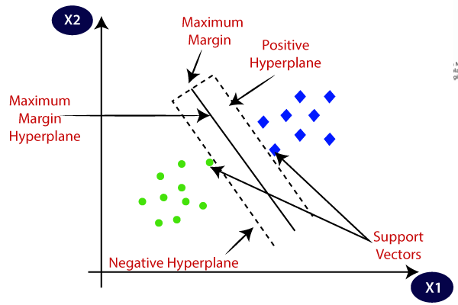

**Example:** SVM can be understood with the example that we have used in the KNN classifier. Suppose we see a strange cat that also has some features of dogs, so if we want a model that can accurately identify whether it is a cat or dog, so such a model can be created by using the SVM algorithm. We will first train our model with lots of images of cats and dogs so that it can learn about different features of cats and dogs, and then we test it with this strange creature. So as support vector creates a decision boundary between these two data (cat and dog) and choose extreme cases (support vectors), it will see the extreme case of cat and dog. On the basis of the support vectors, it will classify it as a cat. Consider the below diagram:

27.6K

Machine Learning - Observational and Experimental Studies

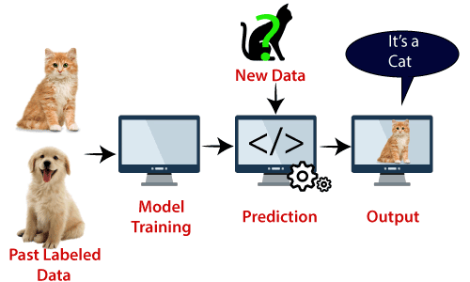

SVM algorithm can be used for **Face detection, image classification, text categorization,** etc.

## Types of SVM

**SVM can be of two types:**

* **Linear SVM:** Linear SVM is used for linearly separable data, which means if a dataset can be classified into two classes by using a single straight line, then such data is termed as linearly separable data, and classifier is used called as Linear SVM classifier.
* **Non-linear SVM:** Non-Linear SVM is used for non-linearly separated data, which means if a dataset cannot be classified by using a straight line, then such data is termed as non-linear data and classifier used is called as Non-linear SVM classifier.

## Hyperplane and Support Vectors in the SVM algorithm:

**Hyperplane:** There can be multiple lines/decision boundaries to segregate the classes in n-dimensional space, but we need to find out the best decision boundary that helps to classify the data points. This best boundary is known as the hyperplane of SVM.

The dimensions of the hyperplane depend on the features present in the dataset, which means if there are 2 features (as shown in image), then hyperplane will be a straight line. And if there are 3 features, then hyperplane will be a 2-dimension plane.

We always create a hyperplane that has a maximum margin, which means the maximum distance between the data points.

**Support Vectors:**

The data points or vectors that are the closest to the hyperplane and which affect the position of the hyperplane are termed as Support Vector. Since these vectors support the hyperplane, hence called a Support vector.

## How does SVM works?

**Linear SVM:**

The working of the SVM algorithm can be understood by using an example. Suppose we have a dataset that has two tags (green and blue), and the dataset has two features x1 and x2. We want a classifier that can classify the pair(x1, x2) of coordinates in either green or blue. Consider the below image:

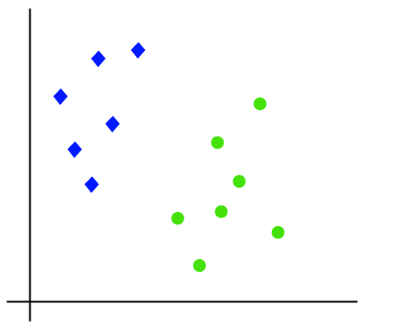

So as it is 2-d space so by just using a straight line, we can easily separate these two classes. But there can be multiple lines that can separate these classes. Consider the below image:

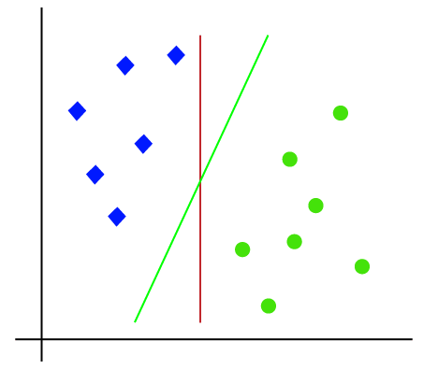

Hence, the SVM algorithm helps to find the best line or decision boundary; this best boundary or region is called as a **hyperplane**. SVM algorithm finds the closest point of the lines from both the classes. These points are called support vectors. The distance between the vectors and the hyperplane is called as **margin**. And the goal of SVM is to maximize this margin. The **hyperplane** with maximum margin is called the **optimal hyperplane**.

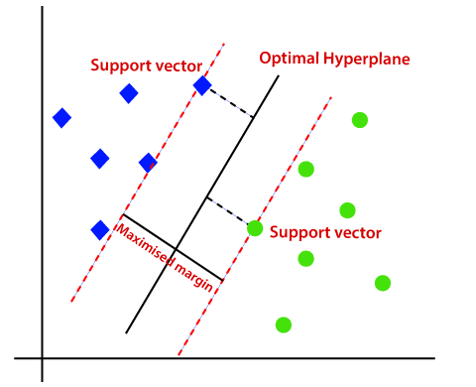

**Non-Linear SVM:**

If data is linearly arranged, then we can separate it by using a straight line, but for non-linear data, we cannot draw a single straight line. Consider the below image:

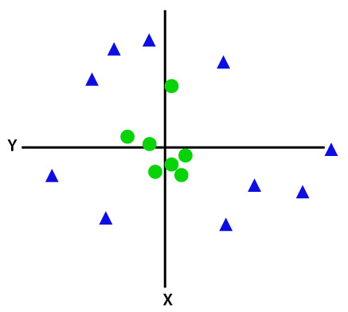

So to separate these data points, we need to add one more dimension. For linear data, we have used two dimensions x and y, so for non-linear data, we will add a third dimension z. It can be calculated as:

z=x2 +y2

By adding the third dimension, the sample space will become as below image:

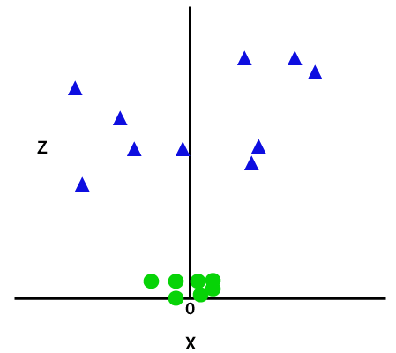

So now, SVM will divide the datasets into classes in the following way. Consider the below image:

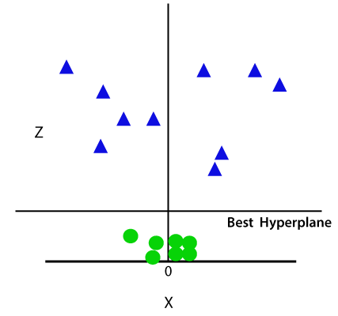

Since we are in 3-d Space, hence it is looking like a plane parallel to the x-axis. If we convert it in 2d space with z=1, then it will become as:

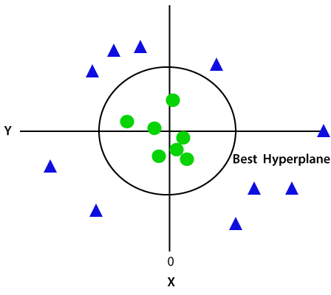

Hence we get a circumference of radius 1 in case of non-linear data.

**Decision Tree Classification Algorithm**

* Decision Tree is a **Supervised learning technique**that can be used for both classification and Regression problems, but mostly it is preferred for solving Classification problems. It is a tree-structured classifier, where**internal nodes represent the features of a dataset, branches represent the decision rules** and **each leaf node represents the outcome.**
* In a Decision tree, there are two nodes, which are the **Decision Node** and**Leaf Node.** Decision nodes are used to make any decision and have multiple branches, whereas Leaf nodes are the output of those decisions and do not contain any further branches.
* The decisions or the test are performed on the basis of features of the given dataset.
* **It is a graphical representation for getting all the possible solutions to a problem/decision based on given conditions.**
* It is called a decision tree because, similar to a tree, it starts with the root node, which expands on further branches and constructs a tree-like structure.
* In order to build a tree, we use the **CART algorithm,** which stands for **Classification and Regression Tree algorithm.**
* A decision tree simply asks a question, and based on the answer (Yes/No), it further split the tree into subtrees.
* Below diagram explains the general structure of a decision tree:

#### **Note: A decision tree can contain categorical data (YES/NO) as well as numeric data.**

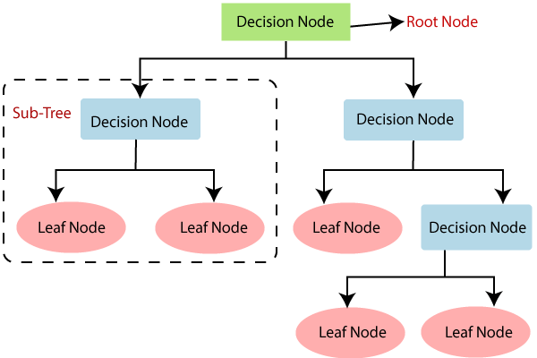

## Why use Decision Trees?

There are various algorithms in Machine learning, so choosing the best algorithm for the given dataset and problem is the main point to remember while creating a machine learning model. Below are the two reasons for using the Decision tree:

* Decision Trees usually mimic human thinking ability while making a decision, so it is easy to understand.
* The logic behind the decision tree can be easily understood because it shows a tree-like structure.

## Decision Tree Terminologies

• **Root Node:** Root node is from where the decision tree starts. It represents the entire dataset, which further gets divided into two or more homogeneous sets.

• **Leaf Node:** Leaf nodes are the final output node, and the tree cannot be segregated further after getting a leaf node.

• **Splitting:** Splitting is the process of dividing the decision node/root node into sub-nodes according to the given conditions.

• **Branch/Sub Tree:** A tree formed by splitting the tree.

• **Pruning:** Pruning is the process of removing the unwanted branches from the tree.

• **Parent/Child node:** The root node of the tree is called the parent node, and other nodes are called the child nodes.

**How does the Decision Tree algorithm Work?**

In a decision tree, for predicting the class of the given dataset, the algorithm starts from the root node of the tree. This algorithm compares the values of root attribute with the record (real dataset) attribute and, based on the comparison, follows the branch and jumps to the next node.

For the next node, the algorithm again compares the attribute value with the other sub-nodes and move further. It continues the process until it reaches the leaf node of the tree. The complete process can be better understood using the below algorithm:Machine Falls Over Backwards and Faceplants to the Water

* **Step-1:** Begin the tree with the root node, says S, which contains the complete dataset.
* **Step-2:** Find the best attribute in the dataset using **Attribute Selection Measure (ASM).**
* **Step-3:** Divide the S into subsets that contains possible values for the best attributes.
* **Step-4:** Generate the decision tree node, which contains the best attribute.
* **Step-5:** Recursively make new decision trees using the subsets of the dataset created in step -3. Continue this process until a stage is reached where you cannot further classify the nodes and called the final node as a leaf node.

**Example:** Suppose there is a candidate who has a job offer and wants to decide whether he should accept the offer or Not. So, to solve this problem, the decision tree starts with the root node (Salary attribute by ASM). The root node splits further into the next decision node (distance from the office) and one leaf node based on the corresponding labels. The next decision node further gets split into one decision node (Cab facility) and one leaf node. Finally, the decision node splits into two leaf nodes (Accepted offers and Declined offer). Consider the below diagram:

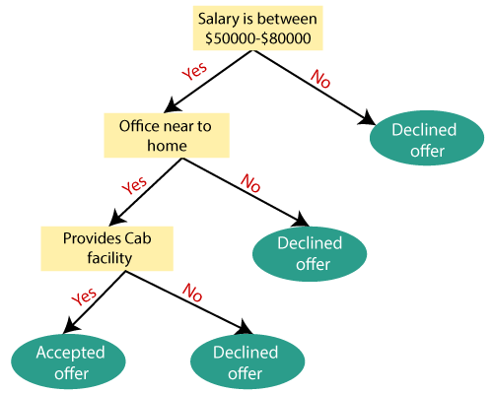

## Attribute Selection Measures

While implementing a Decision tree, the main issue arises that how to select the best attribute for the root node and for sub-nodes. So, to solve such problems there is a technique which is called as **Attribute selection measure or ASM.**By this measurement, we can easily select the best attribute for the nodes of the tree. There are two popular techniques for ASM, which are:

* **Information Gain**
* **Gini Index**

### **1. Information Gain:**

* Information gain is the measurement of changes in entropy after the segmentation of a dataset based on an attribute.
* It calculates how much information a feature provides us about a class.
* According to the value of information gain, we split the node and build the decision tree.
* A decision tree algorithm always tries to maximize the value of information gain, and a node/attribute having the highest information gain is split first. It can be calculated using the below formula:

1. Information Gain= Entropy(S)- [(Weighted Avg) *Entropy(each feature)

**Entropy:** Entropy is a metric to measure the impurity in a given attribute. It specifies randomness in data. Entropy can be calculated as:

Entropy(s)= -P(yes)log2 P(yes)- P(no) log2 P(no)

**Where,**

* **S= Total number of samples**
* **P(yes)= probability of yes**
* **P(no)= probability of no**

### **2. Gini Index:**

* Gini index is a measure of impurity or purity used while creating a decision tree in the CART(Classification and Regression Tree) algorithm.
* An attribute with the low Gini index should be preferred as compared to the high Gini index.
* It only creates binary splits, and the CART algorithm uses the Gini index to create binary splits.
* Gini index can be calculated using the below formula:

Gini Index= 1- ∑jPj2

## Pruning: Getting an Optimal Decision tree

Pruning is a process of deleting the unnecessary nodes from a tree in order to get the optimal decision tree.

A too-large tree increases the risk of overfitting, and a small tree may not capture all the important features of the dataset. Therefore, a technique that decreases the size of the learning tree without reducing accuracy is known as Pruning. There are mainly two types of tree **pruning**technology used:

* **Cost Complexity Pruning**
* **Reduced Error Pruning.**

Python Implementation of Decision Tree

Now we will implement the Decision tree using Python. For this, we will use the dataset "**user_data.csv**," which we have used in previous classification models. By using the same dataset, we can compare the Decision tree classifier with other classification models such as [KNN](https://www.javatpoint.com/k-nearest-neighbor-algorithm-for-machine-learning) [SVM,](https://www.javatpoint.com/machine-learning-support-vector-machine-algorithm) [LogisticRegression,](https://www.javatpoint.com/logistic-regression-in-machine-learning) etc.

Steps will also remain the same, which are given below:

* **Data Pre-processing step**
* **Fitting a Decision-Tree algorithm to the Training set**
* **Predicting the test result**
* **Test accuracy of the result(Creation of Confusion matrix)**
* **Visualizing the test set result**

# **Random Forest Algorithm**

Random Forest is a popular machine learning algorithm that belongs to the supervised learning technique. It can be used for both Classification and Regression problems in ML. It is based on the concept of **ensemble learning,** which is a process of combining multiple classifiers to solve a complex problem and to improve the performance of the model.

As the name suggests, ***"Random Forest is a classifier that contains a number of decision trees on various subsets of the given dataset and takes the average to improve the predictive accuracy of that dataset."*** Instead of relying on one decision tree, the random forest takes the prediction from each tree and based on the majority votes of predictions, and it predicts the final output.

**The greater number of trees in the forest leads to higher accuracy and prevents the problem of overfitting.**

The below diagram explains the working of the Random Forest algorithm:

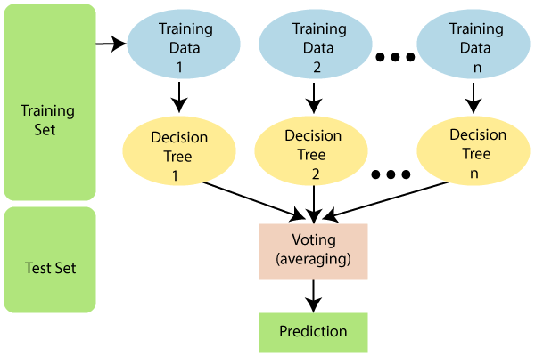

#### **Note: To better understand the Random Forest Algorithm, you should have knowledge of the Decision Tree Algorithm.**

## Assumptions for Random Forest

Since the random forest combines multiple trees to predict the class of the dataset, it is possible that some decision trees may predict the correct output, while others may not. But together, all the trees predict the correct output. Therefore, below are two assumptions for a better Random forest classifier:

* There should be some actual values in the feature variable of the dataset so that the classifier can predict accurate results rather than a guessed result.
* The predictions from each tree must have very low correlations.

## Why use Random Forest?

Below are some points that explain why we should use the Random Forest algorithm:

<="" li="">

* It takes less training time as compared to other algorithms.
* It predicts output with high accuracy, even for the large dataset it runs efficiently.
* It can also maintain accuracy when a large proportion of data is missing.

## How does Random Forest algorithm work?

Random Forest works in two-phase first is to create the random forest by combining N decision tree, and second is to make predictions for each tree created in the first phase.

The Working process can be explained in the below steps and diagram:

**Step-1:** Select random K data points from the training set.

**Step-2:** Build the decision trees associated with the selected data points (Subsets).

**Step-3:** Choose the number N for decision trees that you want to build.

**Step-4:** Repeat Step 1 & 2.

**Step-5:** For new data points, find the predictions of each decision tree, and assign the new data points to the category that wins the majority votes.

The working of the algorithm can be better understood by the below example:

**Example:** Suppose there is a dataset that contains multiple fruit images. So, this dataset is given to the Random forest classifier. The dataset is divided into subsets and given to each decision tree. During the training phase, each decision tree produces a prediction result, and when a new data point occurs, then based on the majority of results, the Random Forest classifier predicts the final decision. Consider the below image:

